ELCT 302
Laboratory Notebook #5
Subsystem Integration: Combination and State Logic
Group #2
Short Circuits
December 8th, 2023

I hereby certify that I have complied
with the Spirit and the Letter
of the Carolinian Creed
in preparing this report

Mady Hines
Mady Hines

Department of Electrical Engineering
University of South Carolina
Columbia, SC 29208
Table of Contents
Time Sheet 3
General Objectives 3
Main Specifications 3
Plan of Action (Procedure) 3
Tasks 3
Button Implementation (Run, Wait, Stop) 4
Faults: 5
Problems 5
Requirements 6

Combined System - Group 2 [Short Circuits]

Time Sheet
Date/Time | Work Done | Teams
11/13: 2 hours | Read Lab 5 requirements, discussed driving team and steering accomplishments with each other to get on same bases. | Steering, Driving
11/30: 5 hours | Combine Drive Team and Steering Team Circuit | Driving
11/30: 2 hours | Combine Drive Team and Steering Team Code | Steering
11/30: 2 hours | Researched and team discussion on pros/cons of different input and fault methods | Steering, Driving
12/01: 8 hours | Battery and Power Supply Voltage Testing and fixing circuits designed for 10V | Driving
12/01: 4 hours | Implemented IR remote interface method [Failed] | Steering
12/03: 3 hours | Closed Loop Feedback Testing for Drive Team [Failed] | Steering
12/02: 10 hours | Determined to NOT use IR remote, removed all existing circuitry, and rebuilt system with pushbuttons and NEW code logic. | Steering
12/03: 4 hours | Initial Testing on Track | Steering, Driving
12/03-6: 45 hours | Initial and overall System Calibration and Optimization: | Steering
12/06: 2 hours | Final System Calibration and Optimization | Steering, Driving
12/03: 2 hours | Replaced drive motor due to failure. | Driving

General Objectives
- Integrate the driving team and steering team
- Implement State Logic for vehicle operation
- System integration
  - Hardware: build necessary circuit and input/output
  - Software: Combine the functions of driving and steering

Main Specifications
- Servo voltage: 4.8V - 6V
- Communication frequency: 50Hz
- Servo Rotational range: 180⁰
- Feedback: LC circuit for a given inductance (at 20 kHz)
- Motor voltage: 7.4V
- Switching frequency: ≥20 kHz
- Speed range: 0-100% unidirectional (Design to match the DC motor’s rated voltage!!!)
- External voltage (speed) reference: 0-3.3V
- Feedback: Reflective Object Sensor

Plan of Action (Procedure)

Tasks
- Put hardware on one chassis
  - Determine which chassis to use [Used Steering Chassis, heavily modified]
- Add circuits and hardware for state logic
  - Bumpers; indicators
- Combine the code of driving and steering
  - Use the structure code provided.
- Interfacing software with user inputs
  - Communication with vehicle
  - Buttons or input devices for Run, Wait, Stop

Button Implementation (Run, Wait, Stop)
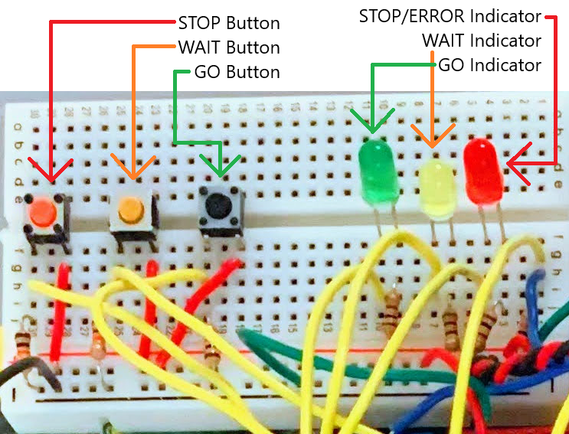
Figure 1. Hardware Setup implementing the buttons. (red=STOP, yellow=WAIT, black=RUN)

System Fault Detection:
- Off-track Fault
  - Chose Method 1 (Both left and right sensors are less than predetermined value[0.1V]) because Lab 4 was skipped and car does not include reflective sensors.
- Collision Fault
  - Chose Method 1 (a bumper on the front of the vehicle)
- 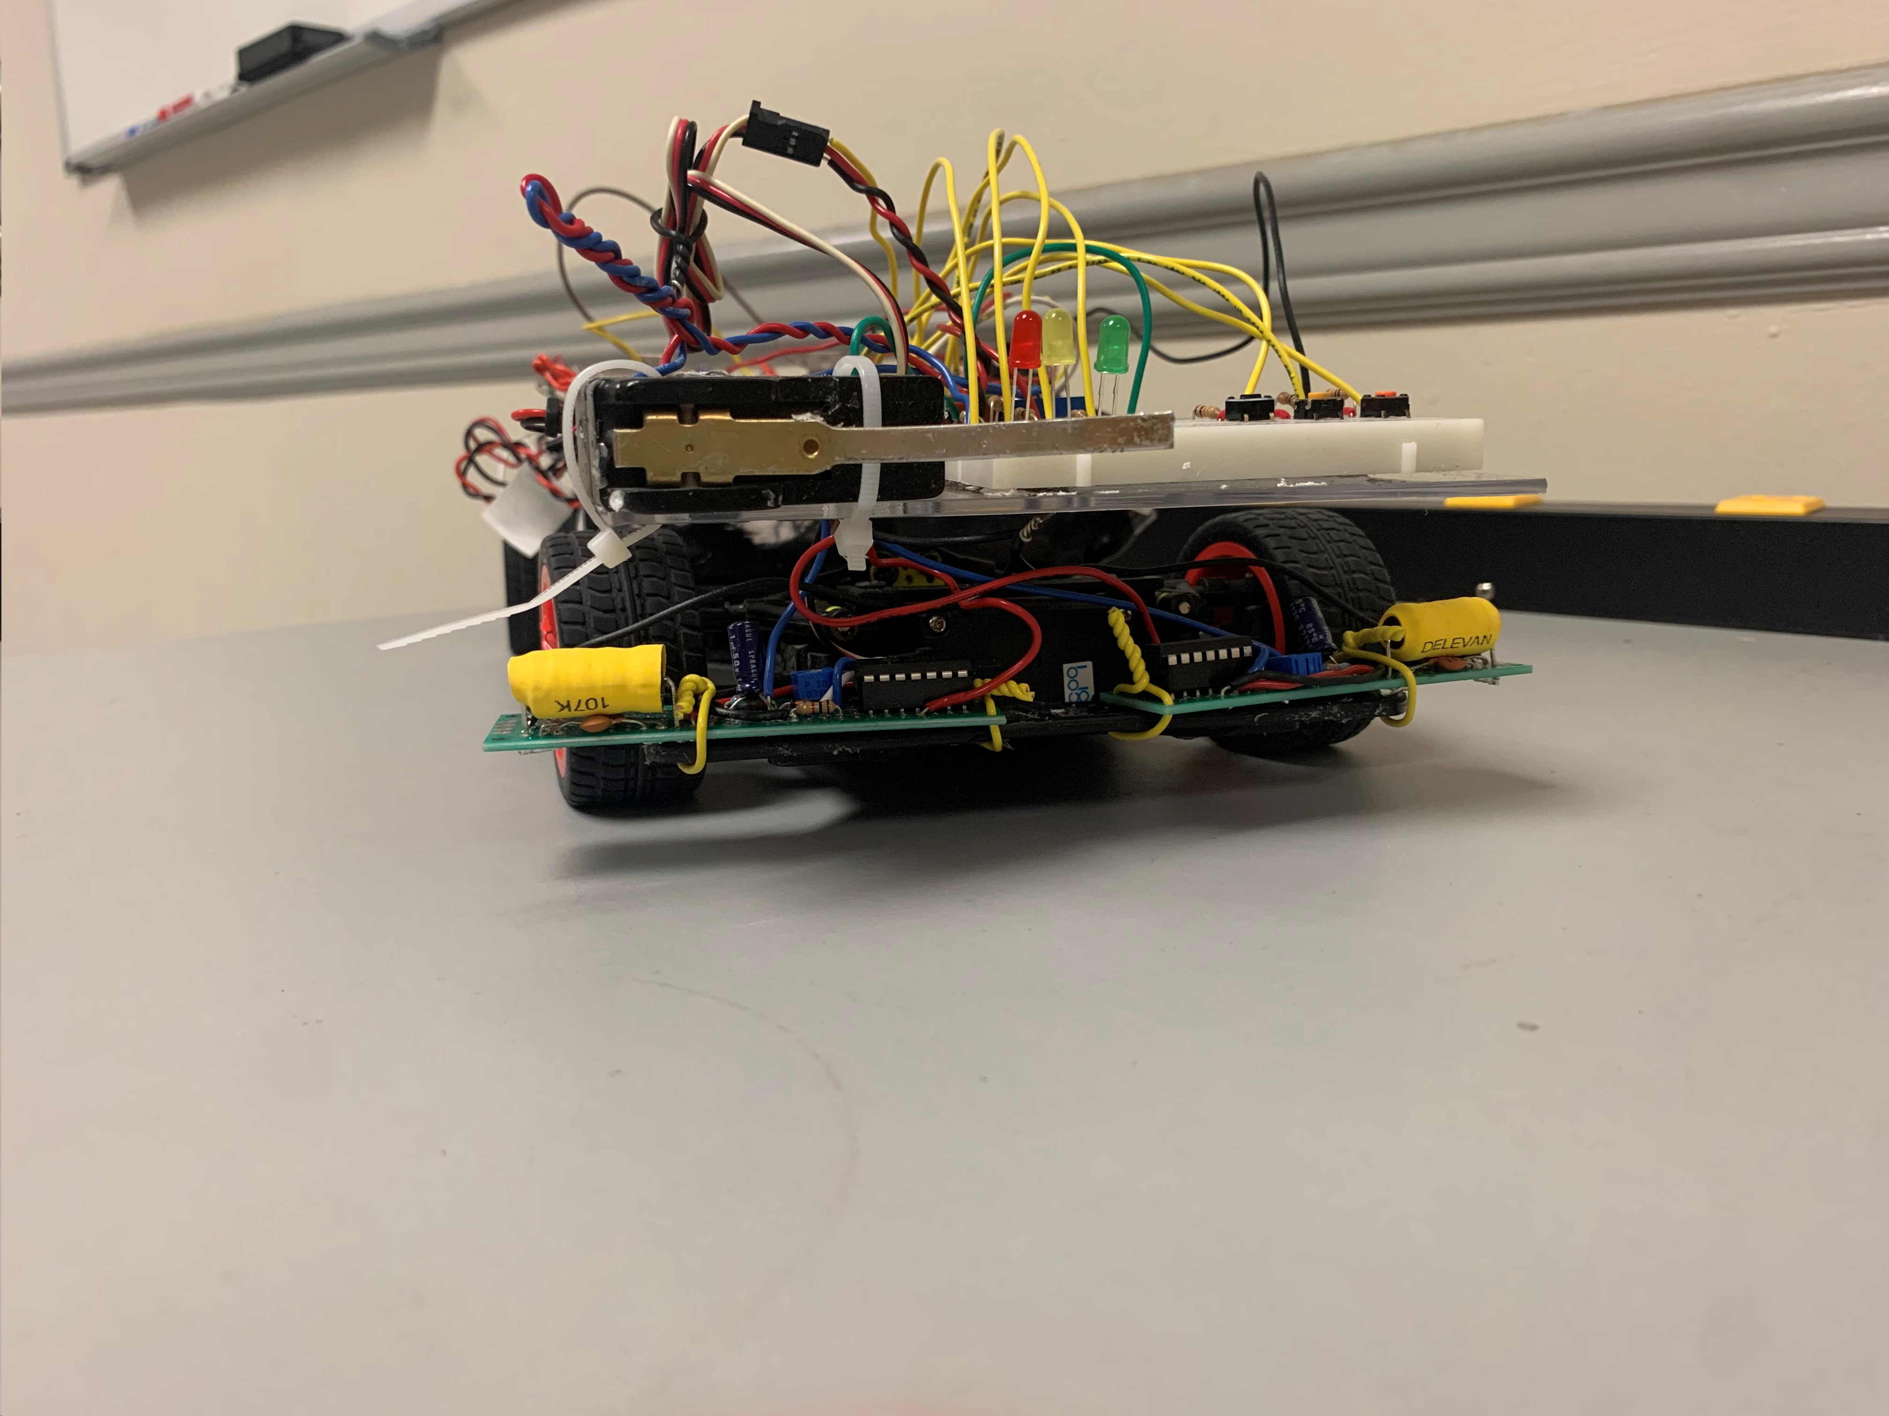
- Figure 3. Bumper on the car.
- Low Battery Voltage Fault
  - Chose Method 1 (Voltage divider from the battery) for simplicity and low power consumption.[Not fully implemented]
Power System Diagram:
The diagram changed slightly due to Arduino boards malfunctioning. Instead of 14.8 V into the Arduino, we modified to have 5V voltage regulated power to Arduino.
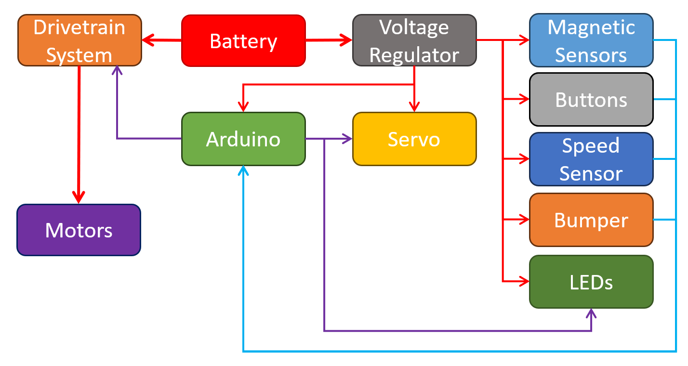

Code Block Diagram:
This is an old version of the Code Block Diagram.
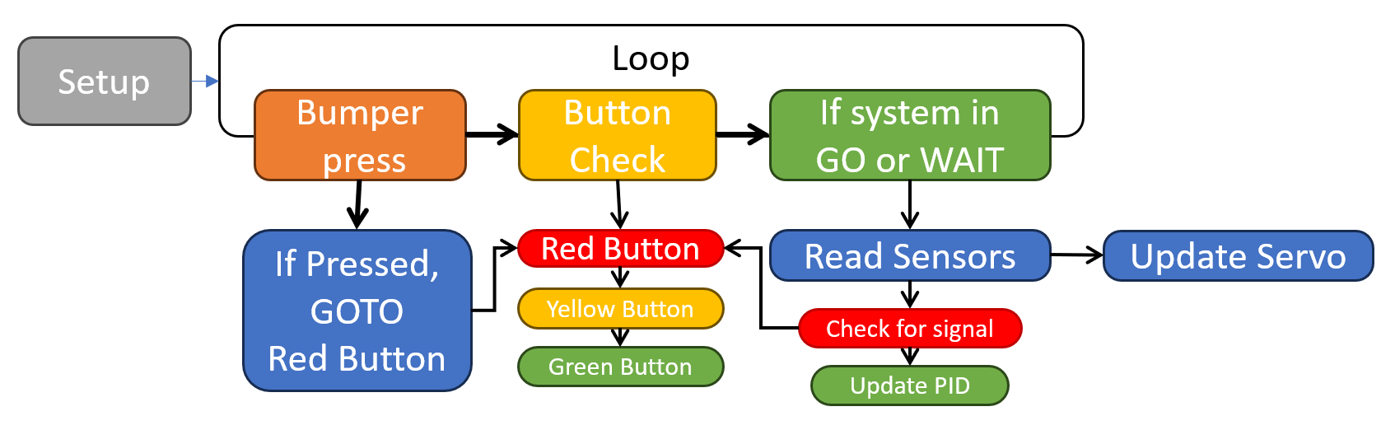
After rewriting the code to include more advanced code techniques, it looks like this:
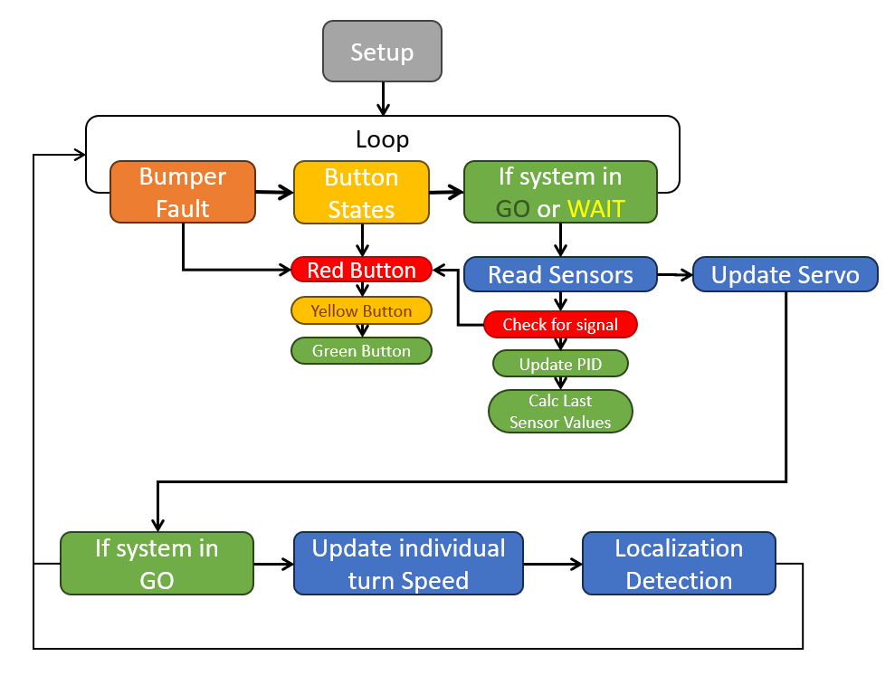
Hardware/Software Interface Diagram
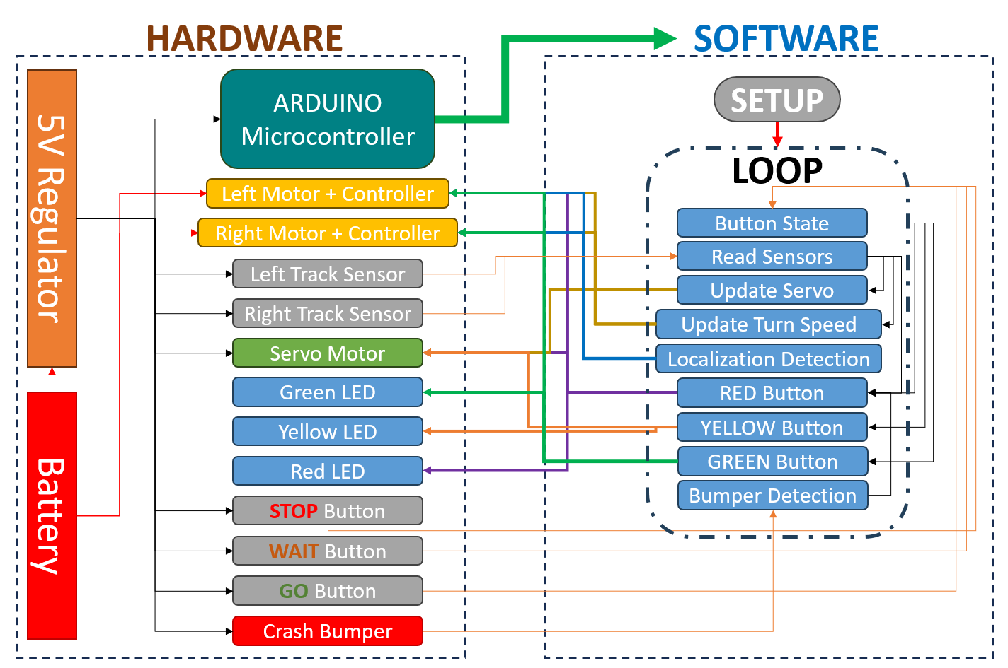

Problems
Potential Issues:
- Microcontroller Incompatibility:
  - Issues: Differences in interfaces, communication protocols, or power requirements.
  - Solution: Select a common microcontroller platform and develop interface adapters.
- Voltage Mismatch:
  - Issues: Inadequate power supply causing performance issues or hardware damage.
  - Solution: Adjust the power supply and use voltage regulators to match requirements.
- Circuitry Failures:
  - Issues: Wiring issues, short circuits, or incorrect component connections.
  - Solution: Inspect and test the circuitry thoroughly; follow correct wiring practices.
- Feedback System Inaccuracies:
  - Issues: Sensor data processing or actuator response time issues.
  - Solution: Calibrate sensors and actuators; optimize data processing algorithms.
- Integration Challenges:
  - Issues: Difficulty ensuring cooperation between driving and steering systems.
  - Solution: Develop integrated control algorithms; conduct extensive system testing.
- Calibration Difficulties:
  - Issues: Challenges in system fine-tuning for optimal performance.
  - Solution: Implement iterative testing and tuning procedures.
- Time and Coordination:
  - Issues: Delays due to task complexity and team collaboration needs.
  - Solution: Implement effective project management and communication strategies.
- Buttons/LEDs Wiring:
  - Issues: Incorrect wiring leading to non-functionality or short circuits.
  - Solution: Double-check wiring against the circuit diagram; use proper connectors.
- Power Supply for LEDs/Buttons:
- Issues: Insufficient voltage or current.
- Solution: Ensure power supply meets component requirements; use current-limiting resistors for LEDs.
- Damaged microcontrollers:
- Issues: Damaged Arduinos.
- Solution: determine issue causing them to crash and destroy. Fixed power wiring.
- Code Implementation Errors:
- Issues: Incorrect code for button inputs or LED control.
- Solution: Review and debug code for logic and syntax; conduct code reviews.
- Button Debounce Issues:
- Issues: "Bouncing" effect leading to multiple signals.
- Solution: Implement software debouncing or use hardware debounce circuits.
- Interrupt Handling:
- Issues: Missed or repeated signals due to improper interrupt management.
- Solution: Correctly configure and manage interrupts; optimize interrupt service routines.
- LED Control Logic Errors:
- Issues: Incorrect LED behavior due to faulty control logic.
- Solution: Check and adjust LED control logic; use PWM for brightness control.
- Implementation Understanding:
- Issues: Lack of knowledge in buttons and LEDs implementation.
- Solution: Research and learn about microcontroller-specific implementation; attend workshops or webinars.

Requirements
- The two sub-team functions are combined
- The state logic is implemented and tested
- Circuits are built for faults
  - Low battery voltage
  - Bumpers
  - Button or other devices for input of RUN, WAIT, STOP
  - Going off track

Final Version of Code for vehicle [Tuned and optimized, Lab6]
// Initialization of the button pins
const int greenButtonPin = 11; // Green button connected to digital pin 2
const int yellowButtonPin = 12; // Yellow button connected to digital pin 3
const int redButtonPin = 8; // Red button connected to digital pin 4

const int servoPin = 5;

double Kp = 22.2, Ki = 0.0, Kd = -2.0;//change from 20 to 21[if car is jittery around corners, increase KD and decrease KP]
//try 30, 0.001, -2.6 for higher speed.s(22.2)

//55 speed= Kp = 15.0, Ki = 0.0001, Kd = -1.3;

double positionError = 0, lastPositionError = 0, integral = 0, derivative = 0, correction = 0;
const int sensorLeft = A3, sensorRight = A2;
const int center=80; //if car isnt centered correctly. Added this
int lastSensorValueLeft = 0, lastSensorValueRight = 0;
const double turnThreshold = 175;
const int zeroPos = 1450; // Slightly right turning at 1500

bool isHandlingHardTurn = false; // New flag

unsigned long turnDetectionStartTime = 0;
unsigned long lastTurnTime = 0;
const unsigned long turnDetectionDelay = 200; // Delay after turn detection in milliseconds

int red = 3;
int yellow = 7;
int green = 4;

const int motorSpeed1=55;//low speed
const int motorSpeed2=58;//low speed

const int motorPinA = 9;
const int motorPinB = 10;
const int bumperPin = 6; // Button pin

unsigned long lastServoUpdate = 0;
const int servoUpdateInterval = 20000; // 20 ms interval for servo update
int servoPulseWidth = zeroPos; // Initial pulse width in microseconds

bool inSteeringMode = false;
bool inWaitingMode = false;
bool inDrivingMode = false;

int sensorValueLeft =0;
int sensorValueRight=0;

void setup() {
// Initialize the button pins as inputs
pinMode(greenButtonPin, INPUT);
pinMode(yellowButtonPin, INPUT);
pinMode(redButtonPin, INPUT);

pinMode(sensorLeft, INPUT); // Set sensor left as input
pinMode(sensorRight, INPUT); // Set sensor right as input
//Serial.begin(9600);
pinMode(red, OUTPUT);
pinMode(green, OUTPUT);
pinMode(yellow, OUTPUT);
pinMode(motorPinA, OUTPUT); // Set motor pin A as output
pinMode(motorPinB, OUTPUT); // Set motor pin B as output
pinMode(bumperPin, INPUT_PULLUP); // Initialize button pin as input with pull-up[NEED TO CHANGE TO NOT BE PULL_UP]
digitalWrite(motorPinA, HIGH); // Initialize motor pin A
digitalWrite(motorPinB, HIGH); // Initialize motor pin B

TCCR1A = 0b11110010; // Timer/Counter Control Registers setup
TCCR1B = 0b00010001;
ICR1 = 320; // Input Capture Register
TCNT1 = 0x0000; // Timer/Counter1 Register
OCR1A = 0; // Turn off motor A
OCR1B = 0; // Turn off motor B

pinMode(servoPin, OUTPUT); // Set servo pin as output
}

void loop() {
checkButtonPress();
handleIRCommands();
if (inSteeringMode || inWaitingMode) {
readAndProcessSensors();
updateServoPosition();

if (inSteeringMode) {
adjustMotorSpeedsBasedOnPID(); // Adjust motor speeds based on PID correction
detectAndHandleTurn();
}
// Serial.print(servoPulseWidth);
// Serial.print(", ");
// Serial.print(sensorValueLeft);
// Serial.print(", ");
// Serial.println(sensorValueRight);
}
}

void adjustMotorSpeedsBasedOnPID() {
if (isHandlingHardTurn) { // Only adjust if in the middle of a hard turn
// Adjust motor speeds based on correction
if (correction / 50 > 150) {
OCR1A = motorSpeed1 - 15; // Slow down left motor for right turn
OCR1B = motorSpeed2; // Keep right motor speed constant
digitalWrite(yellow, HIGH);
} else if (correction / 50 < -150) {
OCR1A = motorSpeed1; // Keep left motor speed constant
OCR1B = motorSpeed2 - 15; // Slow down right motor for left turn
digitalWrite(yellow, HIGH);
} else {
OCR1A = motorSpeed1; // Keep both motors at original speed for straight line
OCR1B = motorSpeed2;
digitalWrite(yellow, LOW);
}
}
}

void detectAndHandleTurn() {
//Kd=-1.9;Kp=24;//LOOK AT THIS BEFORE UPLOADING<---------------------------------------------------------------------------
bool isTurnDetected = abs(center + sensorValueLeft - sensorValueRight) > turnThreshold;

if (isTurnDetected) {
lastTurnTime = millis();
if (turnDetectionStartTime == 0) {
turnDetectionStartTime = millis();
}

if (millis() - turnDetectionStartTime > 30) {
handleTurnDetection();
isHandlingHardTurn = true; // Set flag when handling hard turn
}
} else {
if (turnDetectionStartTime != 0 && millis() - lastTurnTime > turnDetectionDelay) {
digitalWrite(red, LOW);
OCR1A = motorSpeed1 + 15;
OCR1B = motorSpeed2 + 15;
turnDetectionStartTime = 0;
//Kd=3;Kp=10;
isHandlingHardTurn = false; // Reset flag when turn is over
}
}
}

void handleTurnDetection() {
// Turn on Red LED to indicate a turn
digitalWrite(red, HIGH);
OCR1A = motorSpeed1; // Set motor speed left
OCR1B = motorSpeed2; // Set motor speed right
// Additional logic for turn handling can be added here
}

void checkButtonPress() {
if (digitalRead(bumperPin) == HIGH) { // Check if button is pressed
handleRedButton();
}
}

void handleIRCommands() {
// Check if the red button is pressed
if (digitalRead(redButtonPin) == HIGH) {
handleRedButton();
}
// Check if the green button is pressed
if (digitalRead(greenButtonPin) == HIGH) {
handleGreenButton();
}
// Check if the yellow button is pressed
if (digitalRead(yellowButtonPin) == HIGH) {
handleYellowButton();
}

}

void readAndProcessSensors() {
sensorValueLeft = analogRead(sensorLeft);
sensorValueRight = analogRead(sensorRight);

if (sensorValueLeft <= 20 && sensorValueRight <= 20) {
handleRedButton(); // Activate stop mode if both sensors read 0
} else {
calculatePID(sensorValueLeft, sensorValueRight);
updateLastSensorValues(sensorValueLeft, sensorValueRight);
}
}

void calculatePID(int sensorValueLeft, int sensorValueRight) {
positionError = center + sensorValueLeft - sensorValueRight; // Calculate position error + what the code should aim for
integral += positionError; // Accumulate the integral (sum of errors)
derivative = (sensorValueLeft - lastSensorValueLeft) - (sensorValueRight - lastSensorValueRight); // Compute the derivative (rate of change of error)
correction = Kp * positionError + Ki * integral + Kd * derivative; // Calculate the PID correction
}

void updateServoPosition() {
servoPulseWidth = zeroPos + correction / 50;
servoPulseWidth = constrain(servoPulseWidth, 1000, 2000);
if (micros() - lastServoUpdate >= servoUpdateInterval) {
lastServoUpdate = micros();
digitalWrite(servoPin, HIGH);
delayMicroseconds(servoPulseWidth);
digitalWrite(servoPin, LOW);
}
}

void handleRedButton() {
inSteeringMode = false;
inWaitingMode = false;
inDrivingMode = false;
OCR1A = 0; // Turn off motors
OCR1B = 0;
setLEDStates(true, false, false);
}

void handleYellowButton() {
inSteeringMode = false;
inWaitingMode = true;
inDrivingMode = false;
setLEDStates(false, false, true);
}

void handleGreenButton() {
inSteeringMode = true;
inWaitingMode = false;
OCR1A = motorSpeed1; // Set motor speed left
OCR1B = motorSpeed2; // Set motor speed right
integral = 0; // Reset integral component
setLEDStates(false, true, false);
}

void updateLastSensorValues(int sensorValueLeft, int sensorValueRight) {
lastPositionError = positionError;
lastSensorValueLeft = sensorValueLeft;
lastSensorValueRight = sensorValueRight;
}

void setLEDStates(bool redState, bool greenState, bool yellowState) {
digitalWrite(red, redState);
digitalWrite(green, greenState);
digitalWrite(yellow, yellowState);
}

